IMPLEMENT CLASSIFICATION MODEL USING KNN AND COMPUTE EVALUATION METRICS

AIM
To implement a Support Vector Machine (SVM) classification model to predict students' results based on hours studied, attendance, and assignments, and evaluate its performance using accuracy, confusion matrix, and classification report.

ALGORITHM
- Import the required libraries: Pandas, train_test_split, SVC, and evaluation metrics from Scikit-learn.
- Load the dataset from the CSV file data.csv.
- Select Hours_Studied, Attendance, and Assignments as input features.
- Select Result as the target variable.
- Split the dataset into training and testing sets using an 80:20 ratio with random_state=42.
- Create an SVM classifier using SVC(kernel='linear').
- Train the SVM model using the training data with fit().
- Predict the results for the test data using predict().
- Calculate the model's accuracy using accuracy_score().
- Display the confusion matrix using confusion_matrix().
- Generate the classification report using classification_report() to display precision, recall, F1-score, and support.

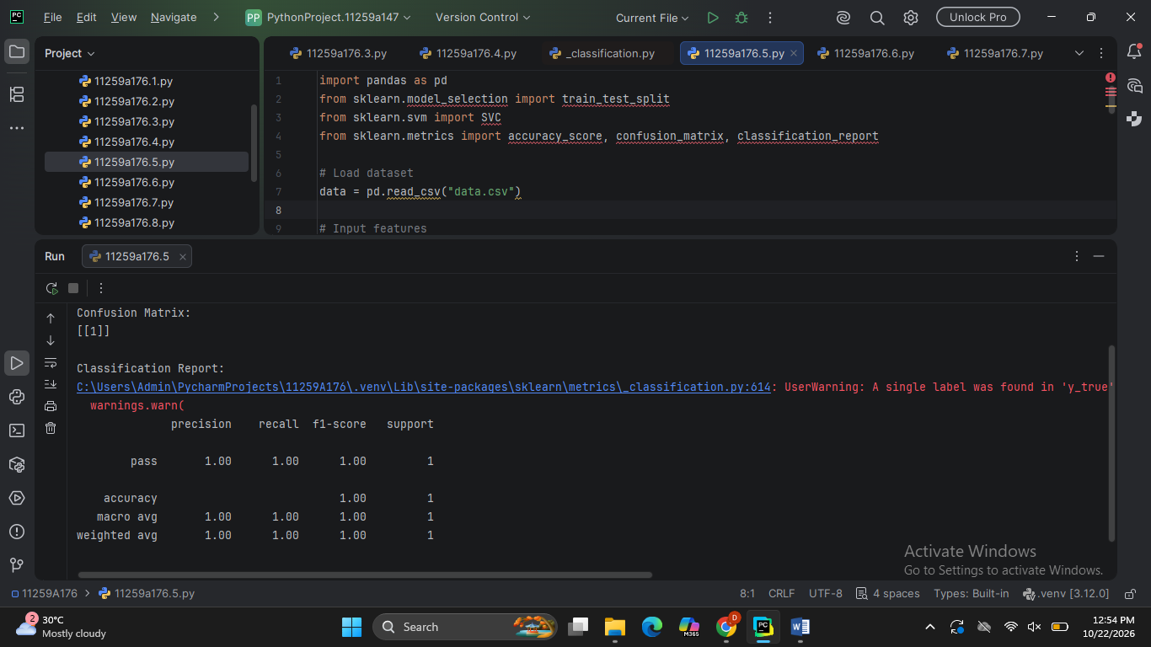

RESULT
The Support Vector Machine (SVM) classification model was successfully implemented using a linear kernel to predict students' results. The model's performance was evaluated using accuracy, a confusion matrix, and a classification report containing precision, recall, F1-score, and support.
The actual evaluation values depend on the dataset in data.csv.

